- IRRIGATION & LANDSCAPING

- Automation and Irrigation & Landscaping Solutions
Automating your irrigation and landscaping work means using smart controllers, sensors, and efficient watering systems to manage irrigation automatically. This modern, hands-free approach can reduce water waste by up to 50%, improve plant health, and eliminate the need for constant manual watering.
Modern automated irrigation and landscaping systems are designed to suit farms, gardens, lawns, parks, and plantation projects. These systems can be customized according to the site condition, plant type, and water requirement.
- Key Components of an Automated Irrigation System

- Smart Controllers & Timers
Smart controllers are the main control units of the system. They allow users to:
- Set irrigation schedules
- Manage multiple watering zones
- Control the system remotely through mobile applications
- Adjust watering automatically based on seasonal requirements
- Soil Moisture & Weather Sensors
Sensors monitor soil moisture levels and local weather conditions. The system waters plants only when required, helping to:
- Prevent overwatering
- Reduce water consumption
- Minimize weed growth
- Improve plant health and survival rate
- Micro-Drip Irrigation & Bubblers
Micro-drip systems and bubblers are ideal for:
- Trees
- Shrubs
- Flower beds
- Miyawaki plantations
These systems deliver water directly to the root zone at a slow and controlled rate, reducing evaporation and runoff losses.
- Pop-Up Sprinkler Systems
Pop-up sprinklers are suitable for:
- Lawns
- Turf areas
- Landscaped gardens
- Open green spaces
The sprinklers remain hidden underground and automatically pop up during irrigation operation, ensuring efficient and uniform watering coverage.
- Benefits of Irrigation Automation
- Saves water and energy
- Reduces labour and maintenance costs
- Improves plant growth and survival
- Ensures uniform irrigation
- Enables remote monitoring and control
- Increases operational efficiency
Automated irrigation and landscaping systems are an ideal solution for modern agriculture, plantations, commercial landscapes, residential gardens, and urban green projects.

- Rain Gun Irrigation System

Rain gun irrigation is a high-discharge, large-radius sprinkler system that sprays water over vast areas (20 to 60-meter radii) in a pattern mimicking natural rainfall. It is highly effective for close-planted, tall, and large-area crops like sugarcane, wheat, and fodder, and requires significantly less water and labor than traditional flood irrigation
Rain Gun Irrigation is a powerful sprinkler-based irrigation system designed to cover large agricultural areas with high-pressure water spray similar to natural rainfall.
- Key Features of Rain Gun Irrigation
- Covers a large area with a spray radius of approximately 27 to 60 meters
- Operates under medium to high water pressure
- Provides uniform water distribution across fields
- Suitable for both field crops and landscaping applications
- Reduces water wastage compared to flood irrigation
- Common Applications
Rain gun systems are highly effective for:
- Sugarcane
- Wheat
- Maize
- Fodder crops
- Groundnut
- Cotton
- Large lawns and landscaping
- Miyawaki plantation irrigation
- Dust suppression in industrial areas
- Key Specifications and Requirements
- Operating Pressure: Requires high pressure ranging from \(2.0\) to \(7.5 { kg/cm}^2\).

- Flow Rate & Coverage: Discharge rates typically range from \(3\) to \(30 { liters per second (lps)}\). One setup can often irrigate roughly half an acre in under 2 hours.

- Adjustability: Most systems allow you to set the sweep angle from partial circles (e.g., \(90^{\circ }\) or \(180^{\circ }\) for edges) to full \(360^{\circ }\) continuous rotation.

- Advantages
- Water Efficiency: Consumes up to \(50\%\) less water than traditional surface or flood irrigation.

- Crop Health: The "rain" effect clears dust off crop leaves, accelerating photosynthesis and naturally preventing certain pest and insect attacks.

- Labor & Cost: Reduces the need to lay down dense network piping across expansive, uninterrupted fields.

- Chemical Application: Easily allows for the broadcast distribution of liquid fertilizers and pesticides alongside regular watering.

- Limitations
- Pressure Dependency: Requires robust pumping systems. If water pressure drops, the system will not throw water to its full radius or rotate properly.

- Land Constraints: Better suited for broad field crops. Because of the heavy droplet size and wide radius, it is not ideal for delicate, precise, plant-level irrigation.

- Fountains

A "Fountains Project" could refer to a few different concepts depending on whether you are interested in DIY landscaping, commercial musical fountains, or scientific physics experiments.
1. DIY Garden & Patio Fountain Projects
- Planter or Ceramic Pot Fountain: This involves stacking two to three different sized pots, running a submersible water pump through them, and sealing the gaps to create a tiered, cascading effect.

- Upcycled Features: Many builders use discarded items like old tires, terracotta pots, or repurposed sinks to create rustic, budget-friendly waterfalls.

- Essential Materials: You will need a submersible pump, PVC tubing or flexible hose, waterproof sealant, and a basin reservoir lined with a pond liner or geo-textile fabric
- Landscaping Components and Services
- Landscaping work is broadly categorized into two main components: soft scaping (living elements like plants and turf) and hardscaping (non-living structural elements like patios and walls). These components are executed through different types of services, ranging from initial design and physical installation to ongoing maintenance and specialty projects.
- Landscaping work is generally divided into three major categories: Soft scaping, Hardscaping, and Maintenance & Specialty Services. Each category plays an important role in creating attractive, functional, and sustainable outdoor spaces.

1. Soft scaping Services
Soft scaping focuses on the living and natural elements of landscaping, enhancing the beauty and environmental value of outdoor areas.

Key Soft scaping Services
- Landscape Design
Planning garden layouts, selecting suitable plants, and creating planting schemes according to local climate and soil conditions.
- Planting & Installation
Installing lawns, trees, shrubs, flowers, hedges, and vegetable gardens.
- Tree & Shrub Care
Pruning, trimming, pest and disease management, tree removal, and stump grinding.
- Turf & Lawn Care
Lawn mowing, fertilization, aeration, weed control, and turf maintenance for healthy green landscapes.

Common Softscape Elements

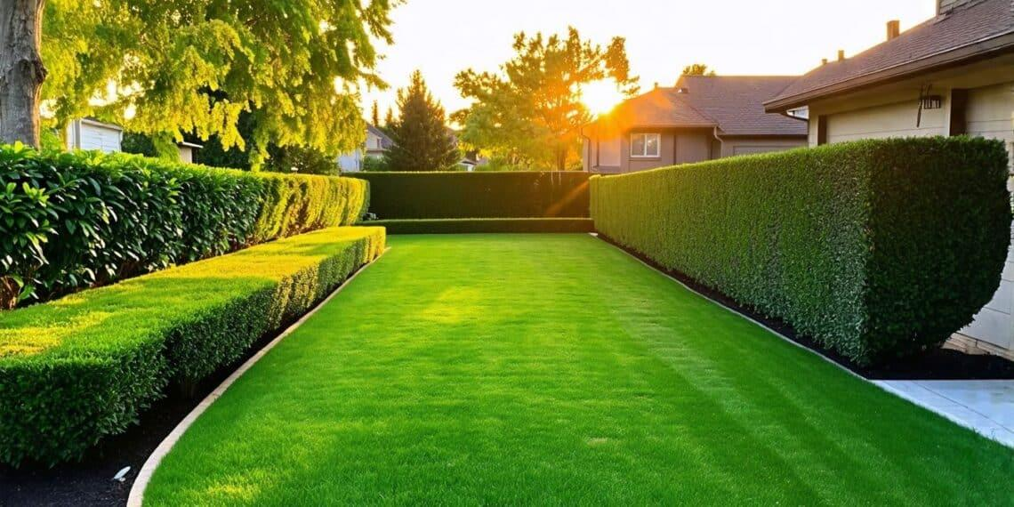

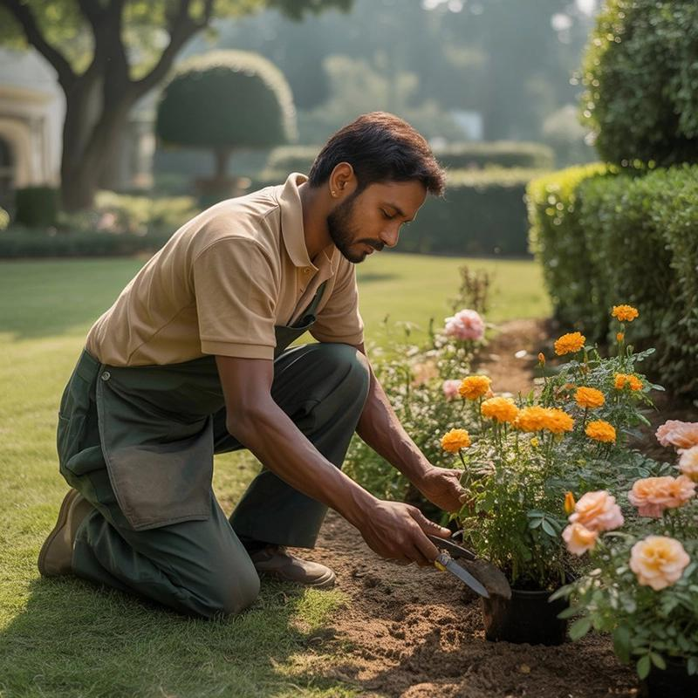

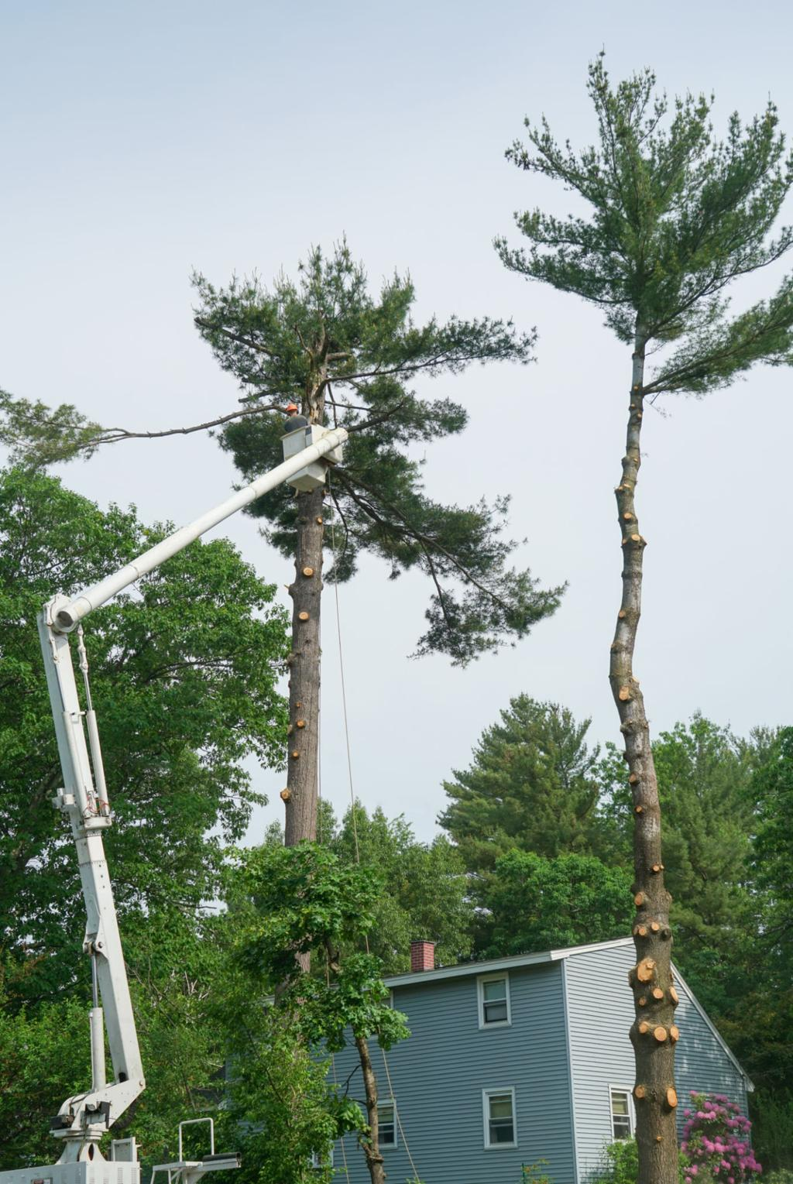
7

2. Hardscaping Services
Hardscaping includes the non-living structural components that provide functionality, accessibility, and long-term durability.

Key Hardscaping Services
- Paving & Walkways
Construction of patios, pathways, driveways, and sitting areas using concrete, pavers, stone, brick, or gravel.
- Retaining Walls
Structural walls built to prevent soil erosion and support terraced landscaping on slopes.
- Outdoor Living Structures
Installation of pergolas, gazebos, decks, seating spaces, and outdoor kitchens.
- Water Features & Fountains
Creating ponds, waterfalls, fountains, and decorative water elements.

Common Hardscape Elements
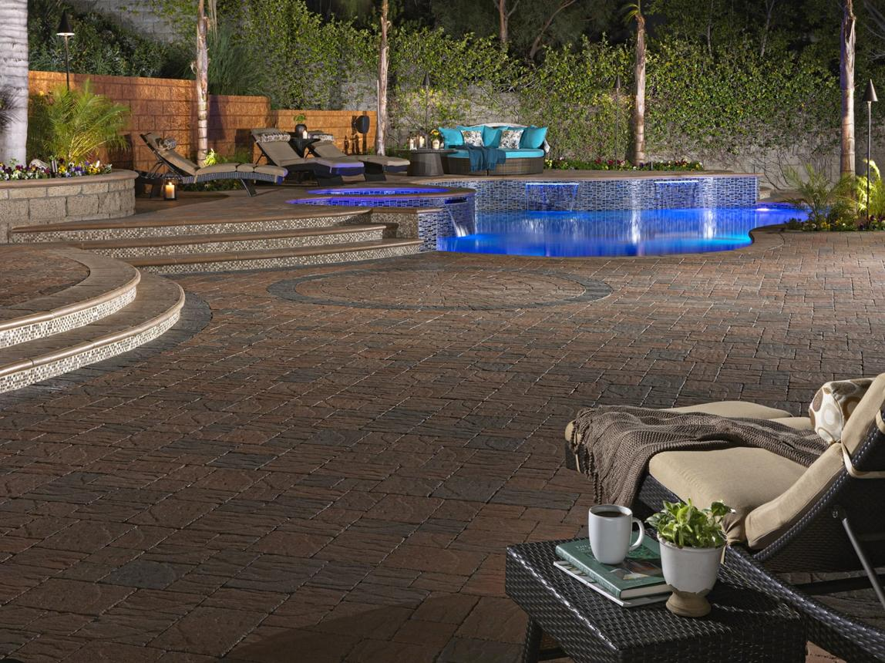

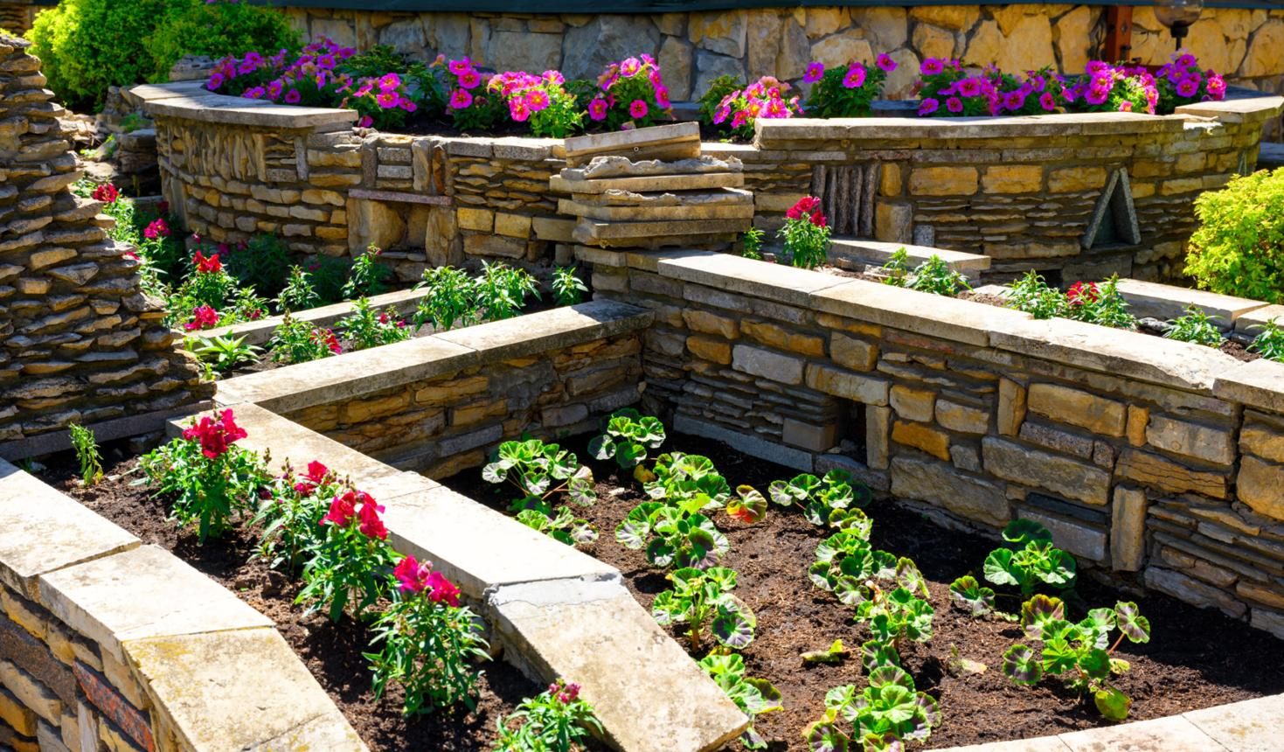
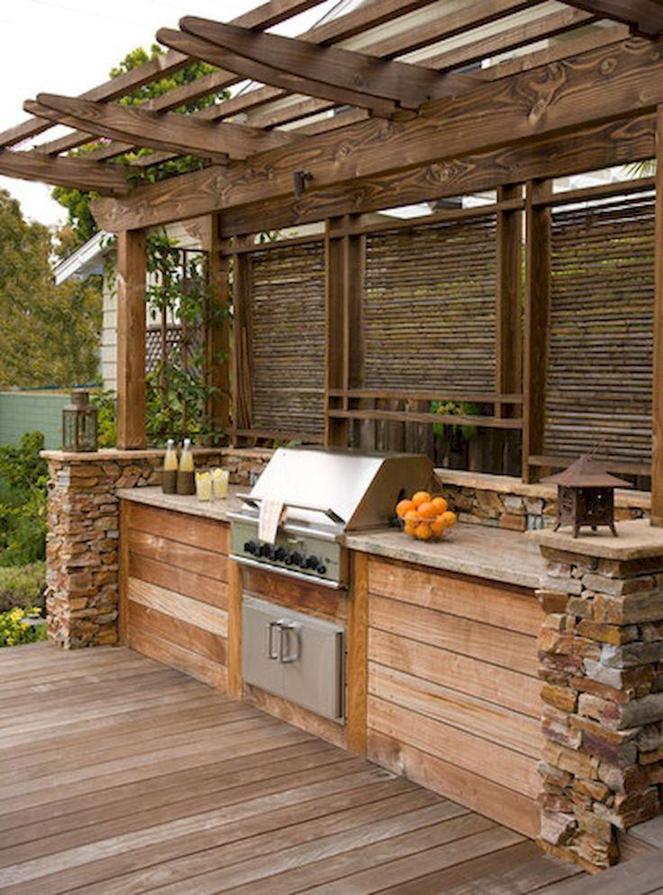
7

3. Maintenance & Specialty Services
These services ensure the landscape remains healthy, clean, safe, and visually appealing throughout the year.

Key Maintenance Services
- General Landscape Maintenance
Seasonal clean up, mulching, trimming, leaf removal, and routine garden care.
- Drainage & Grading
Land levelling and drainage system installation to prevent waterlogging and soil erosion.
- Landscape Lighting
Installing outdoor lighting systems for aesthetics, pathway visibility, and security.

Maintenance and Specialty Work
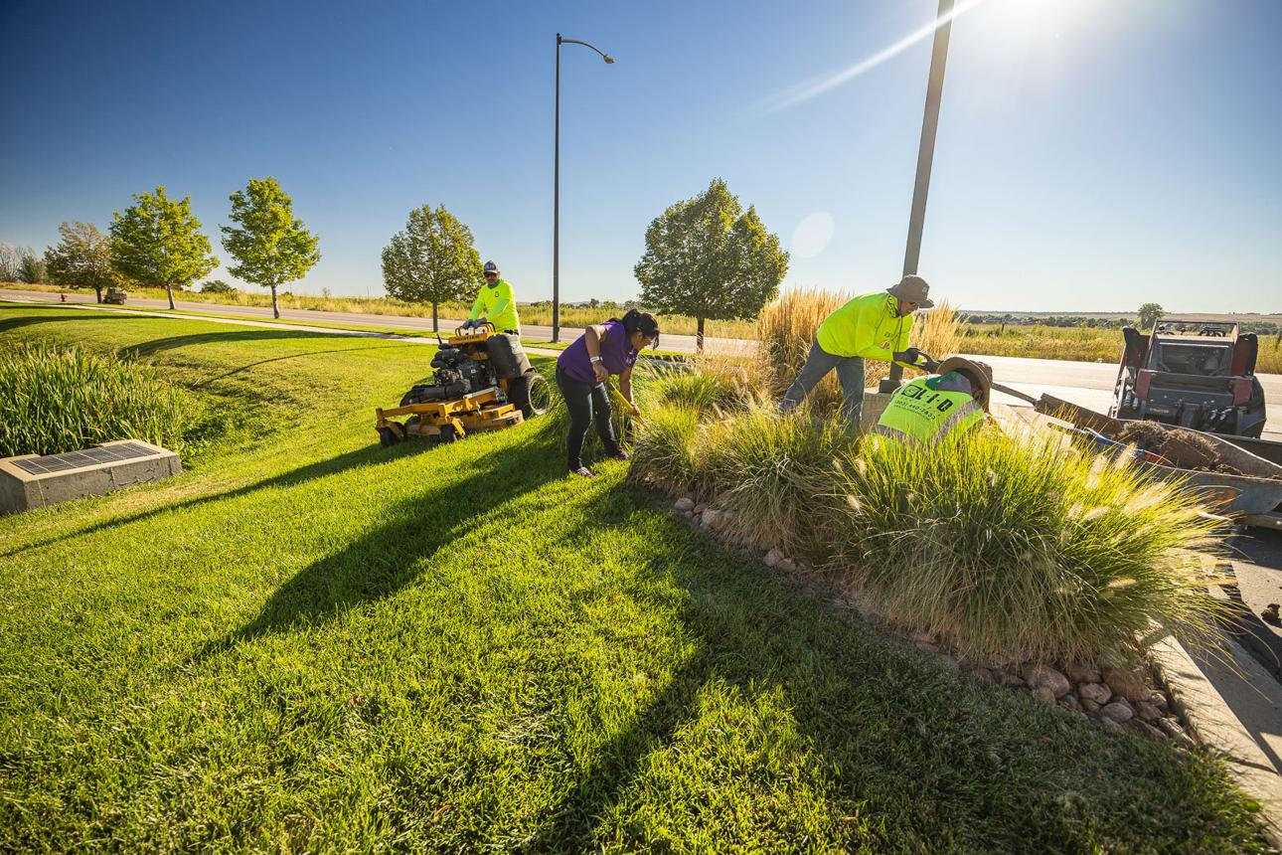

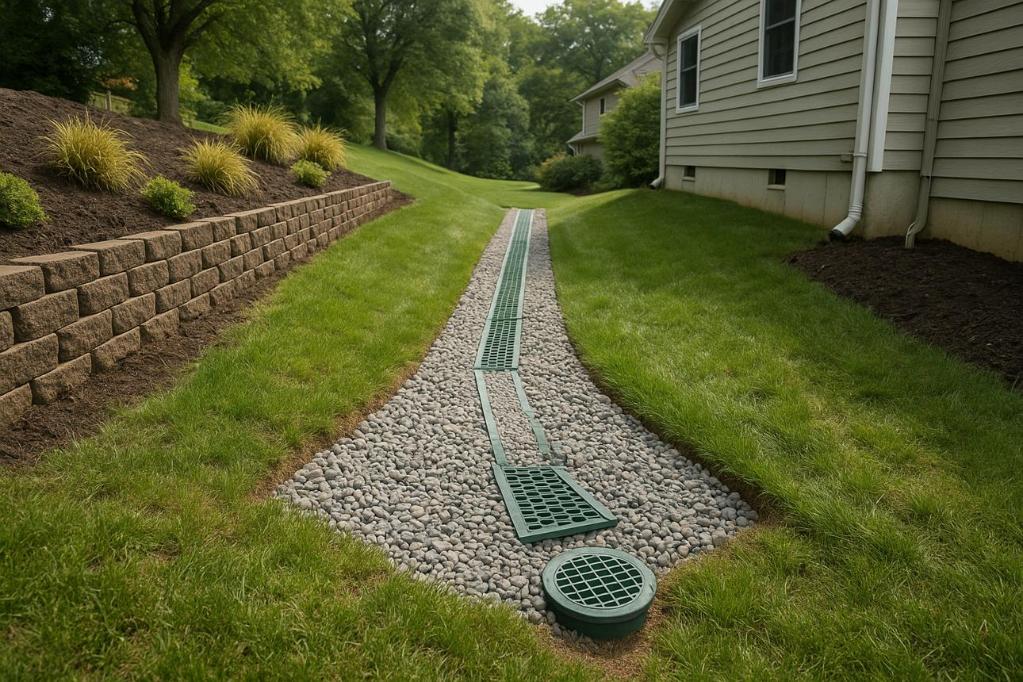

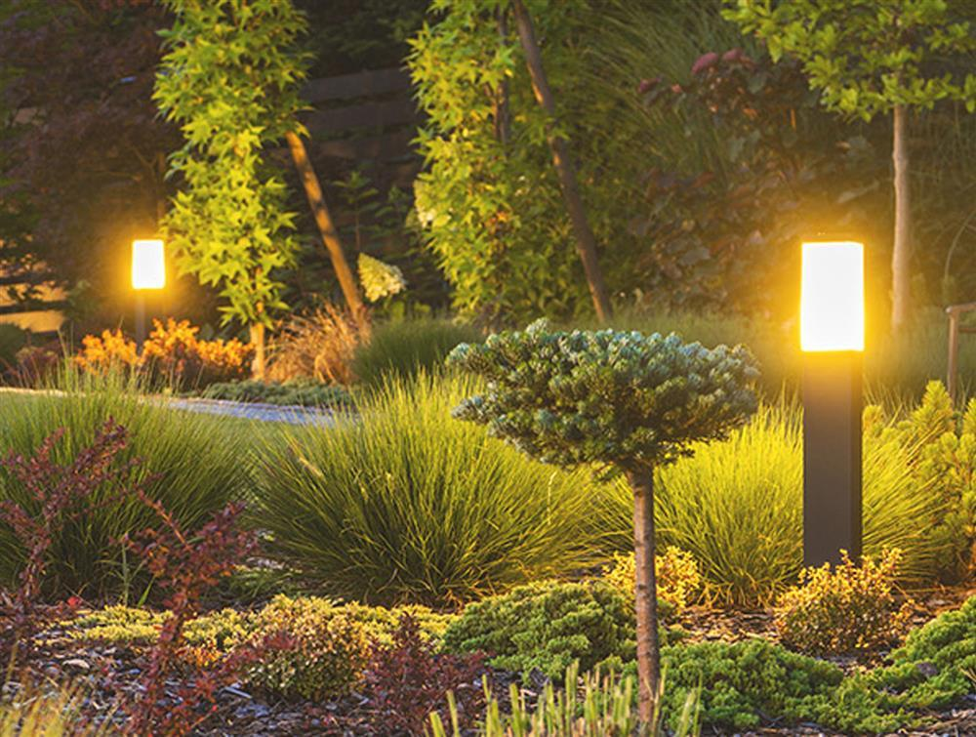
9

Importance of Professional Landscaping
Professional landscaping improves:
- Property appearance and value
- Water management and soil protection
- Outdoor comfort and usability
- Environmental sustainability
- Long-term maintenance efficiency
A balanced combination of soft scaping and hardscaping creates a durable, attractive, and functional outdoor environment for residential, commercial, and agricultural projects.
- Tropical Forest (Miyawaki)
The Miyawaki method is a Japanese afforestation technique that creates dense, native forests that grow up to 10 times faster than conventional plantations. Developed by Akira Miyawaki, this method involves planting a diverse mix of native species very close together in multiple layers, including shrubs, sub-trees, and canopy trees.
The close plantation density encourages rapid growth through natural competition for sunlight, while the use of indigenous species helps restore local biodiversity and ecological balance. Within just 2 to 3 years, the plantation begins developing into a self-sustaining mini forest that requires minimal maintenance.
Miyawaki forests offer several environmental benefits, including:
- Improved air quality
- Increased groundwater retention
- Reduction in urban heat
- Enhanced biodiversity
- Carbon absorption and climate resilience
This technique is widely used in urban greening projects, industrial landscapes, highways, schools, and community environmental initiatives due to its fast growth and long-term sustainability.
🌳 Core Principles
The method is rooted in natural reforestation and relies on three main concepts:
- Native Species Only: Utilizes trees, shrubs, and groundcovers that naturally thrive in the local climate and soil.

- High-Density Planting: Plants 3 to 5 saplings per square meter to encourage vertical growth and force roots downward as plants compete for sunlight.

- Layered Ecosystem: Replicates a natural, multi-tiered forest consisting of shrubs, sub-trees, main trees, and canopy trees.

🌍 Key Benefits

- Rapid Growth: Grows a mature-looking mini-forest in a fraction of the time it takes conventional forests (e.g., reaching maturity in 20-30 years instead of hundreds).

- High Biodiversity: Supports a significantly higher variety of birds, insects, and microorganisms than traditional monoculture plantations.

- Self-Sustaining: Requires human intervention (watering and weeding) for only the first 2-3 years, after which the forest canopy becomes dense enough to shade out weeds and lock in moisture.

- Climate Resilience: Highly effective in urban areas, acting as powerful carbon sinks and offering protection against extreme heat, storms, and noise.

You are located near Bhuj, which is famously home to Smritivan in the Bhujio Dungar hills—the world's largest Miyawaki forest. Spanning hundreds of acres, this massive afforestation project was created as a tribute to the victims of the 2001 earthquake, transforming the rocky terrain into a sprawling, self-sustaining ecosystem of native trees.
Yes — Smritivan Earthquake Memorial and Museum in Bhuj is widely recognized as one of the world’s largest Miyawaki-style afforestation and memorial landscape projects. Built on the historic Bhujiyo Dungar hills, the project combines ecological restoration, memorial architecture, water conservation, and native biodiversity development.
The memorial was developed to honour those who lost their lives in the devastating 2001 Gujarat earthquake. What was once barren, rocky terrain has been transformed through large-scale plantation of native species using dense afforestation techniques inspired by the Miyawaki method.
Key highlights include:
- Dense native forest plantations designed for rapid ecological recovery.
- Large-scale rainwater harvesting and watershed management systems.
- Restoration of biodiversity with indigenous trees and shrubs adapted to Kutch’s arid climate.
- Memorial spaces, museums, viewing points, and educational exhibits integrated into the landscape.
- Improved microclimate and soil stabilization across the hill slopes.
The project is also notable because Miyawaki plantations are usually implemented on small urban plots, whereas Smritivan demonstrates how dense native afforestation principles can be adapted to a massive landscape-scale ecological restoration effort in semi-arid terrain.

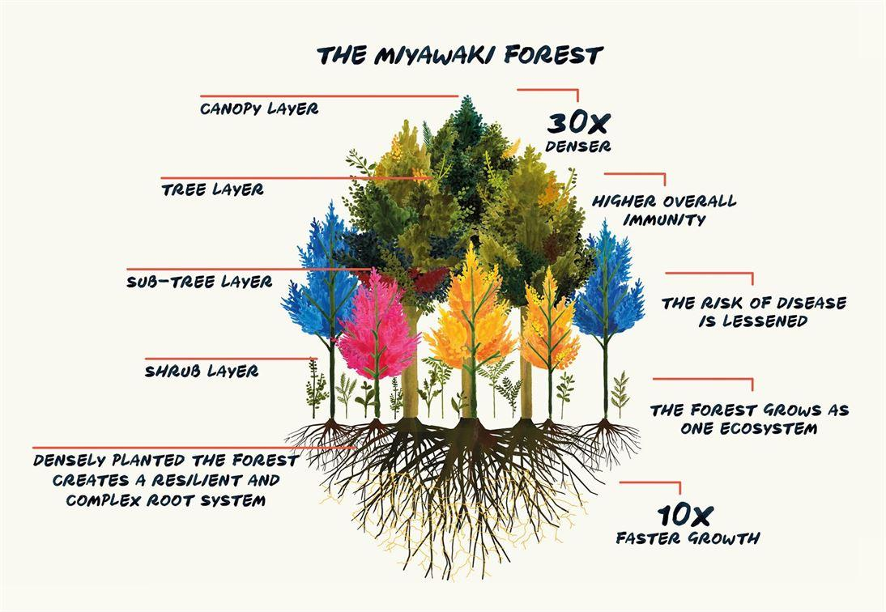

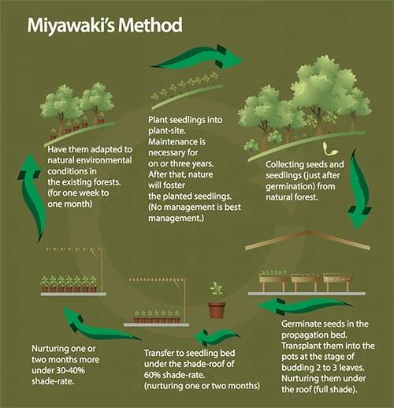

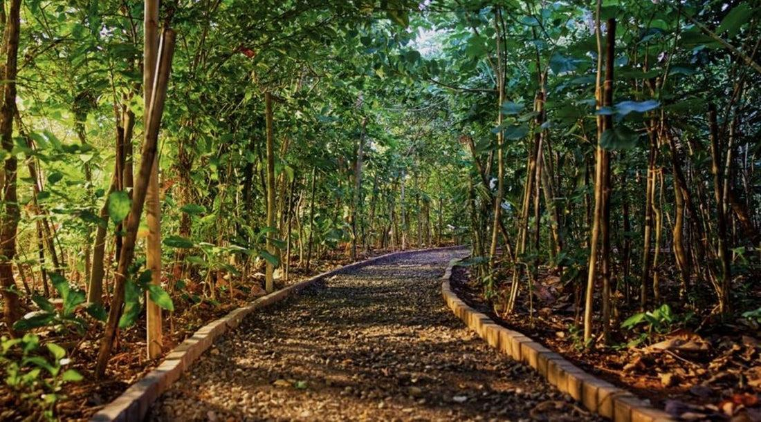

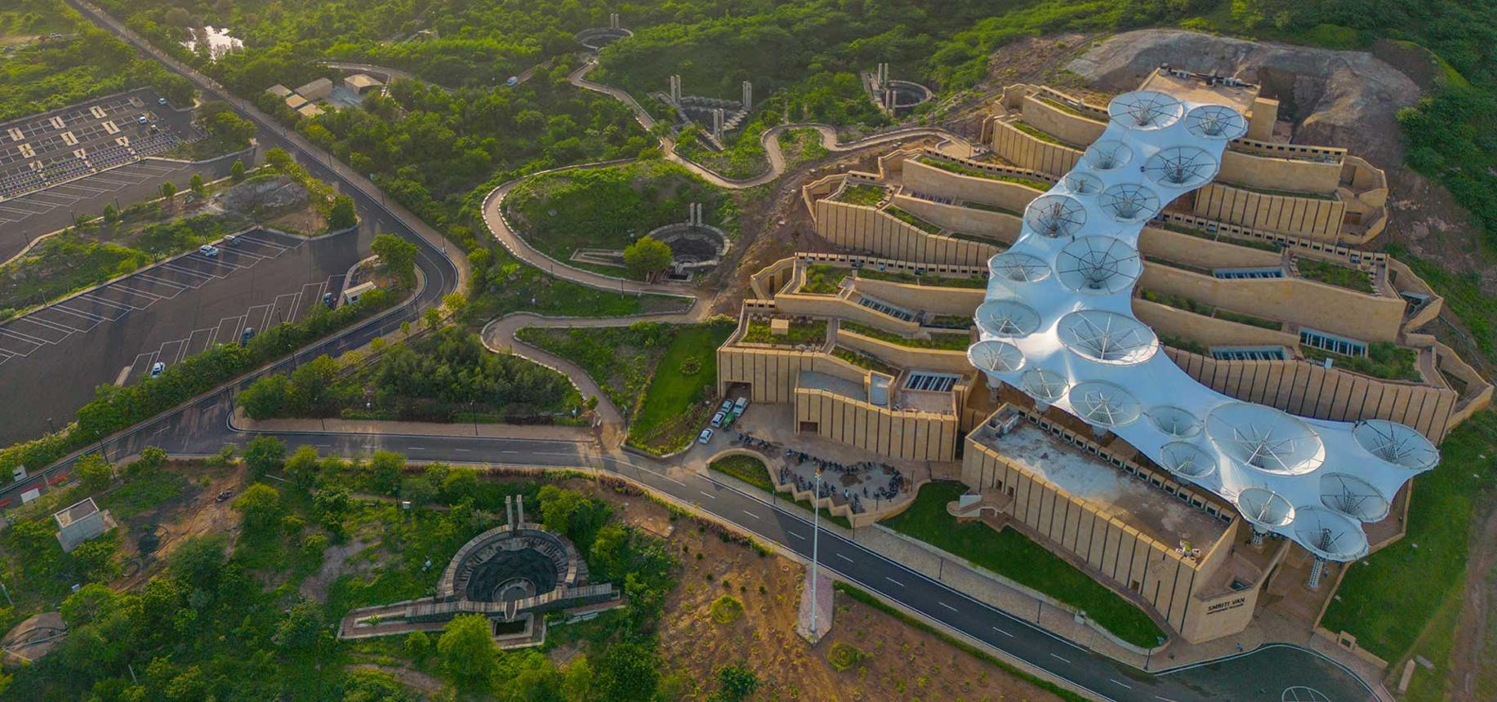

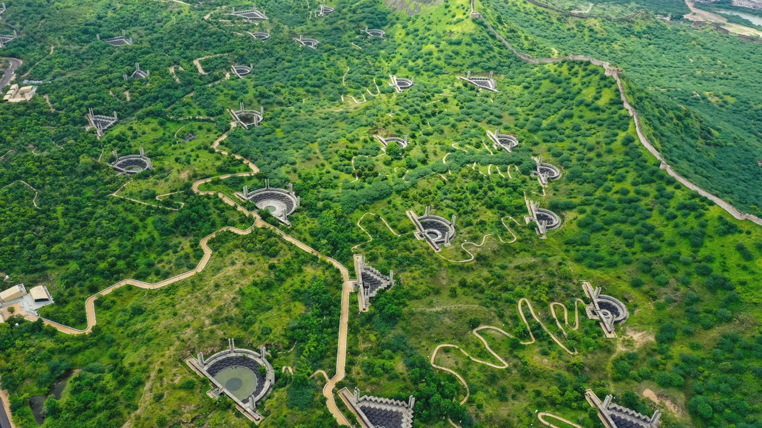

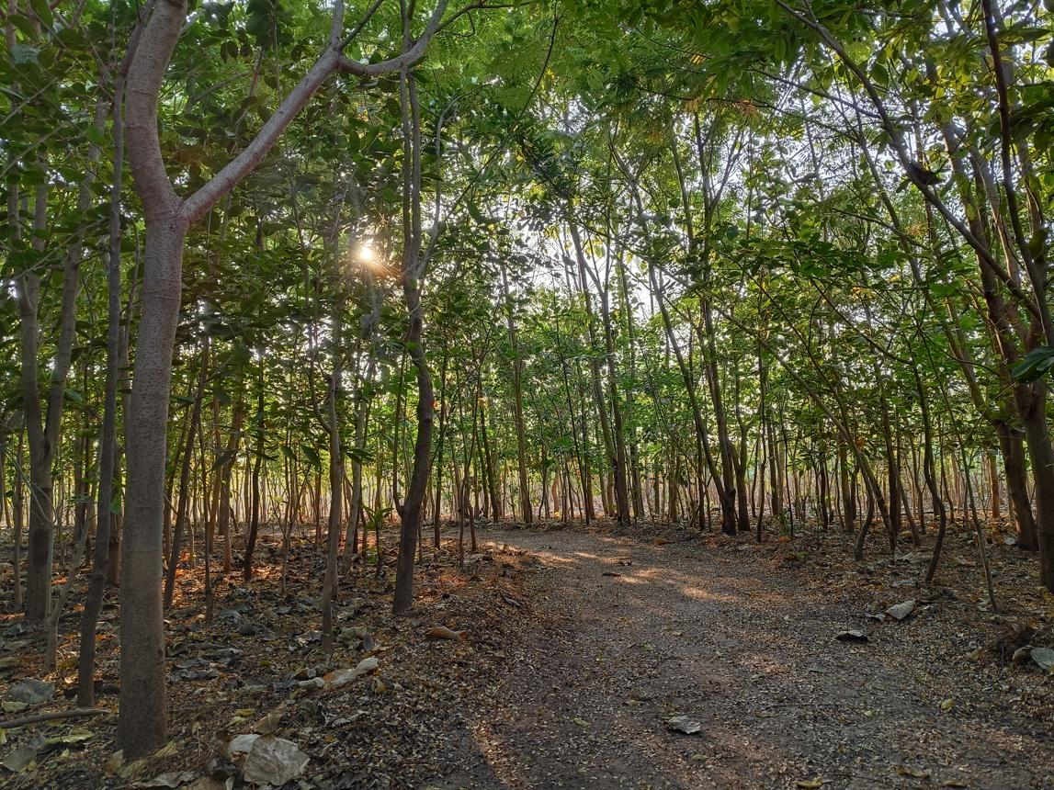

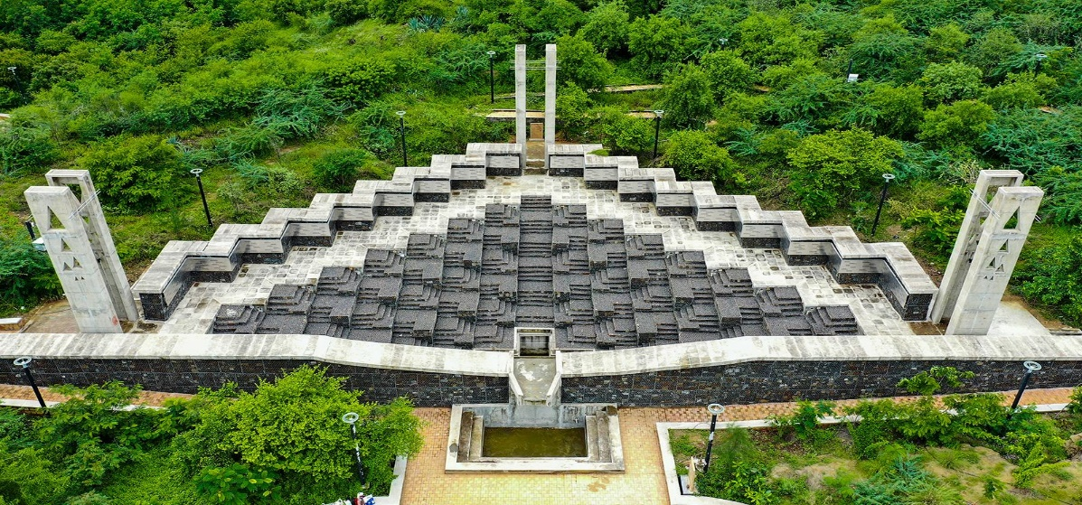

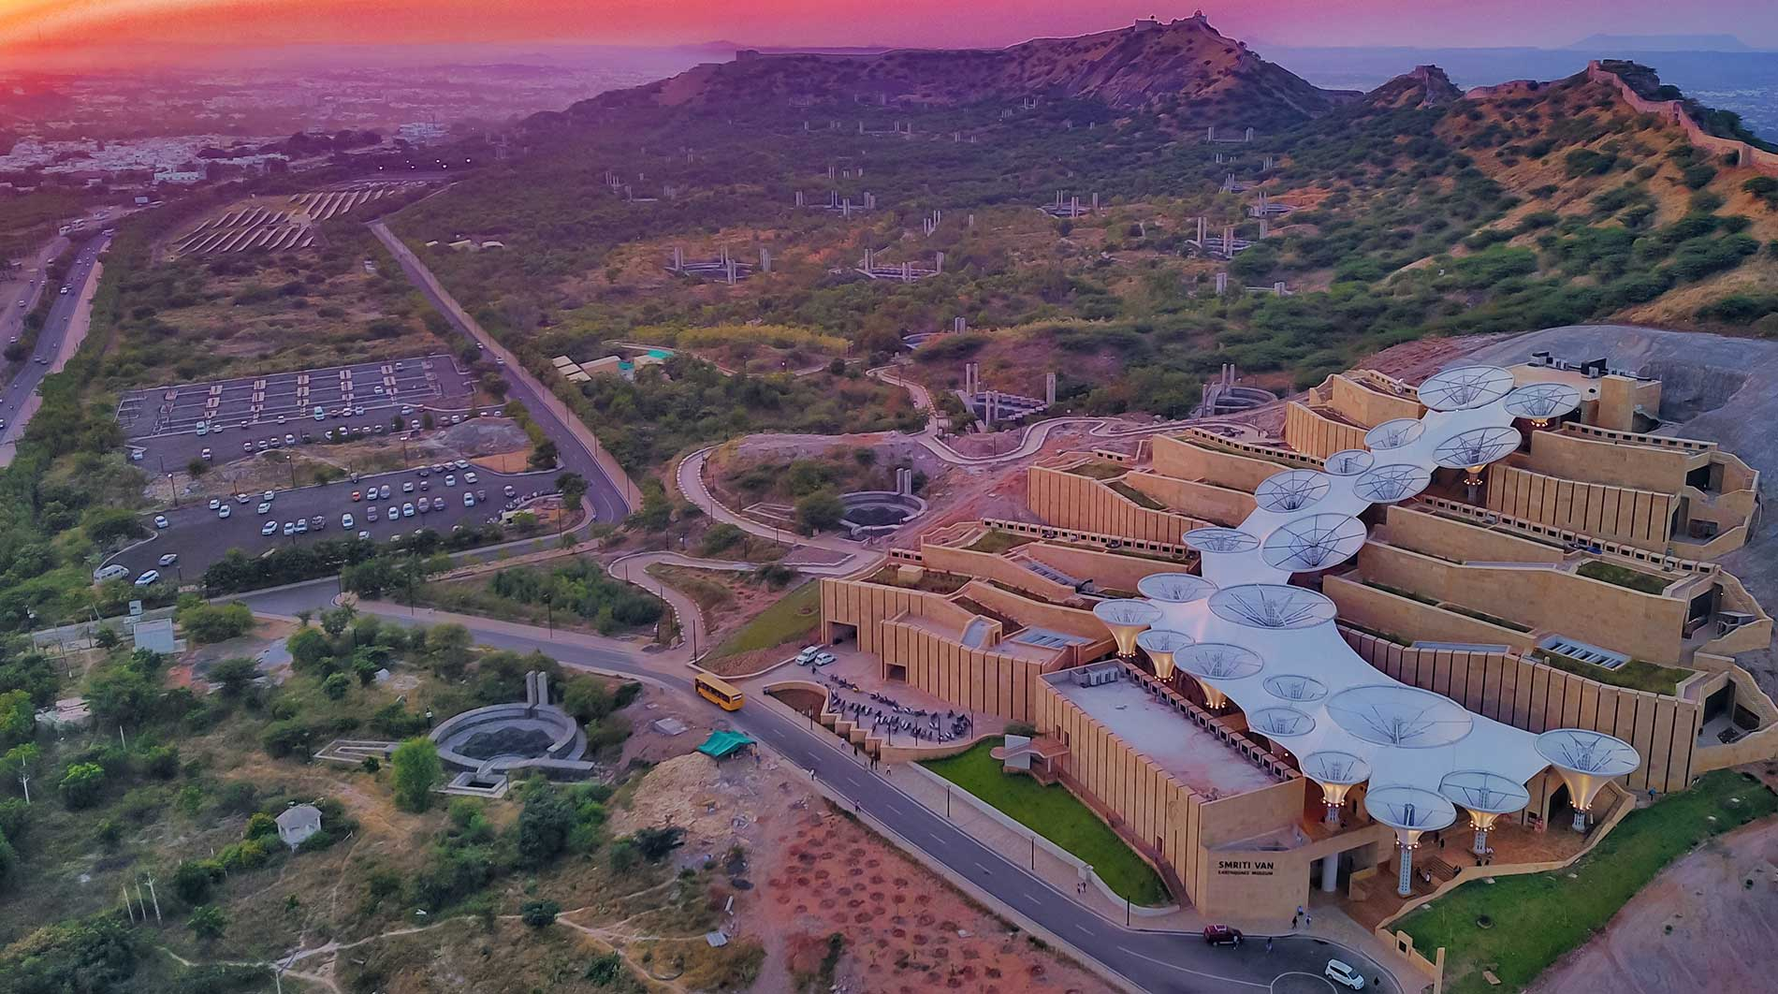

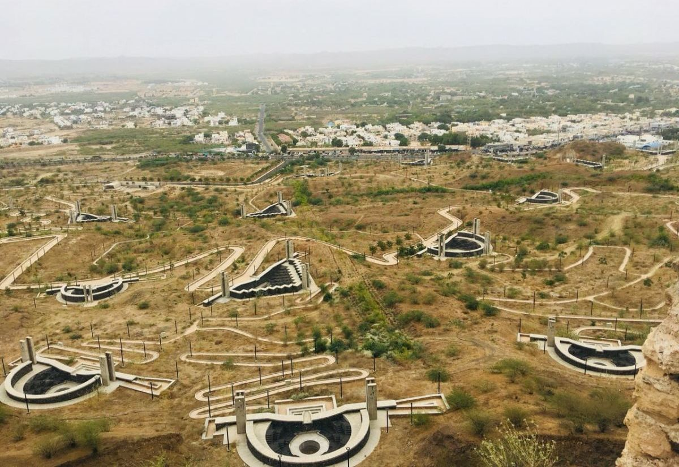

Vertical Gardens

Vertical gardens, also known as green walls or living walls, are designed to grow plants upward on a wall or specially built structure rather than outward on the ground. They maximize space in urban environments, insulate buildings, and improve both indoor and outdoor air quality
Common Vertical Garden Systems
- Modular Systems: These feature interlocking grid panels or plastic modules pre-filled with potting soil or specialized grow media. They are perfect for herbs and easy to maintain.

- Pockets and Pouches: Made from durable, breathable felt or geotextile fabric, these are stapled or mounted directly onto walls. They are lightweight and highly adaptable for DIY projects.

- Trellis and Tower Systems: Stackable planters or wire trellises are ideal for climbing plants, vining vegetables (like tomatoes or cucumbers), and cascading florals.

- Hydroponic Walls: Soil-free systems that use nutrient-rich water circulating through the roots. These are generally lighter and ideal for indoor commercial or high-end residential setups.

- Steps to Build a Living Wall
- Assess the Location: Choose a wall that matches the light requirements of your intended plants. Ensure the structural wall can support the weight of wet soil and plants.

- Install Waterproofing: Protect the mounting wall from moisture damage. For large outdoor or indoor walls, install a waterproof backer board or a plastic moisture barrier.
- Set Up the Frame: Anchor a sturdy framework—such as an iron rack or treated wood—to the wall.

- Choose Your Media: For fabric or hanging pocket systems, choose a lightweight, moisture-retentive medium like Sphagnum moss, which is excellent at preventing rot.

- Install Irrigation: Gravity-fed drip irrigation is best for vertical gardens. Place a water reservoir at the top to trickle down, with a drainage tray at the bottom to prevent waterlogging.

- Best Plant Selections
Selecting the right plants depends highly on your local climate and sunlight exposure:
- For Sunny Spots: Succulents, rosemary, thyme, lavender, and sedum thrive in high sunlight and handle heat well.

- For Shady or Indoor Spots: Ferns, pathos, peace lilies, and monsters do exceptionally well in lower-light environments.

- For Cascading & Textures: Spider plants, creeping jenny, and sweet potato vines provide beautiful drape and fill in gaps quickly.

For tips on how to design and plant a wall to keep your greenery looking full and vibrant:

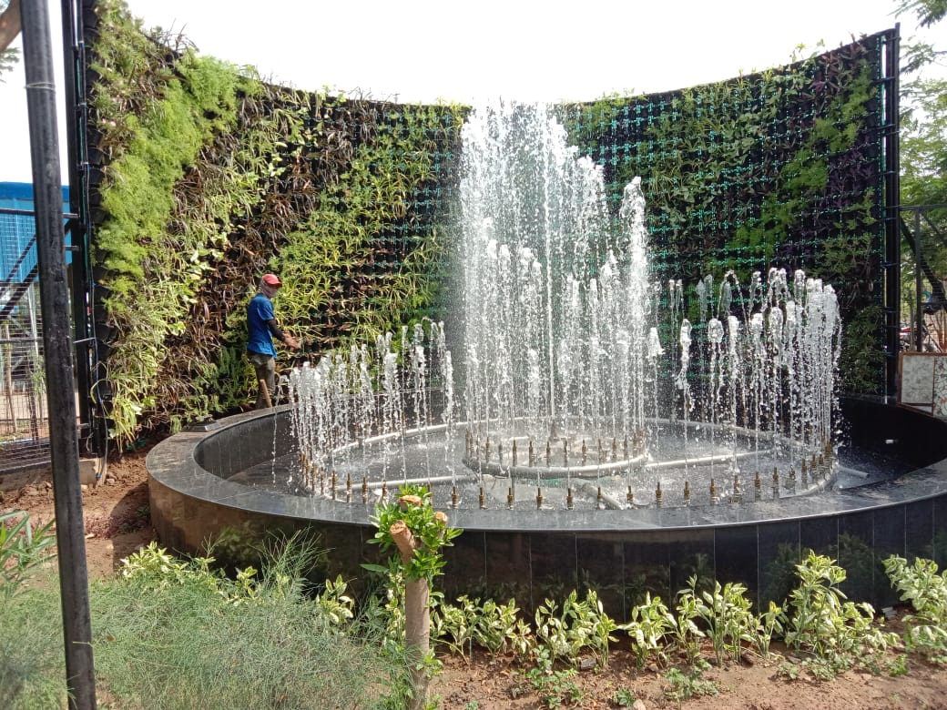

Our Outlets (Mall & Nursery)

  - Jal Mall – Bhachau
  - Neelkanth Nursery – Bhuj
  - Bholenath Nursery – adas, Anand
  - Boondh Agritech – Unnao - UP
  - Garden Care – Ayodhya - UP

Manufacturing Products – Joint Venture of

Inoventive Filaments Pvt Ltd., - Business Channel Partner

Correction Details.

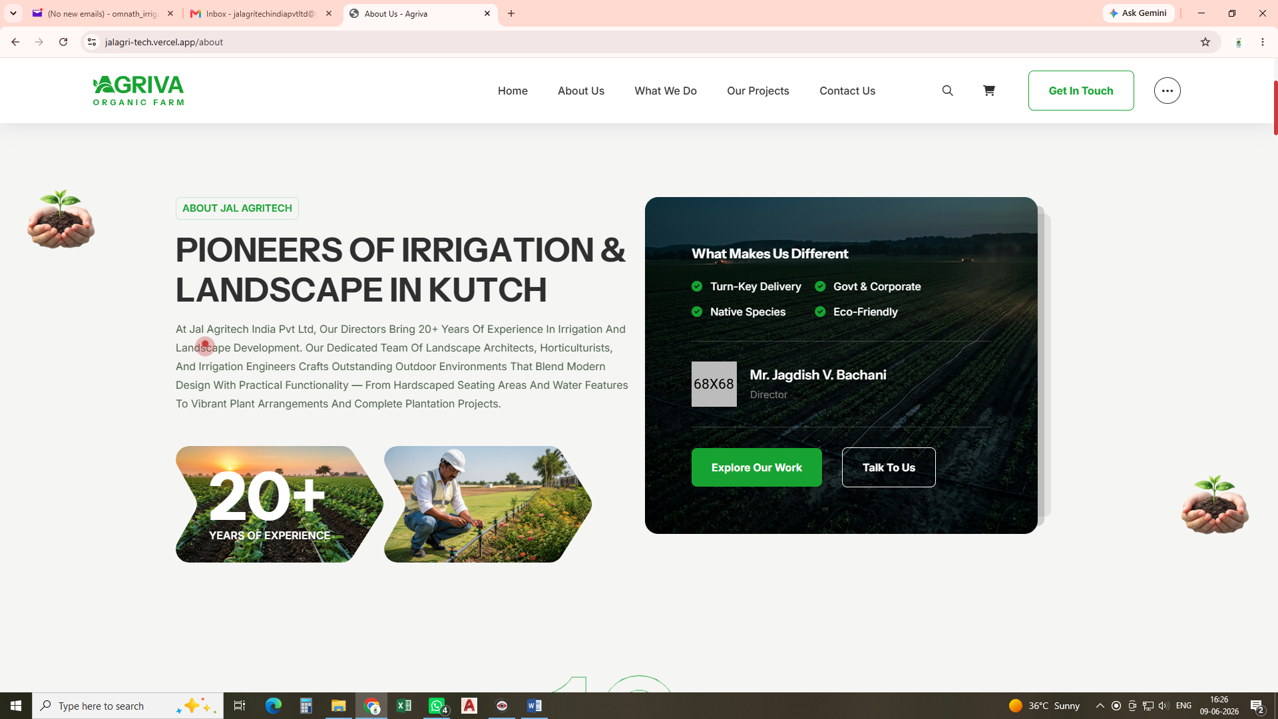

Director Name : Jagdish Bachani,
Parsotam Bachani
"The Directors of Jal Agritech India Private Limited were previously operating an irrigation business under the name Omnath Irrigation & Neelkanth Nursery. To strengthen its market presence and establish it as a recognized brand, Jal Agritech India Private Limited was incorporated in 2020. Since then, the company has been providing comprehensive irrigation, automation, landscaping nursery & agricultural solutions under a structured corporate framework."
"Omnath Irrigation & Neelkanth Nursery, founded and managed by the Directors of Jal Agritech India Private Limited, has been serving the irrigation & nursery sector for several years. In 2020, Jal Agritech India Private Limited was established to transform this business into a professional and trusted brand, delivering innovative irrigation, automation, landscaping, nursery and agricultural solutions across diverse sectors."
To strengthen market presence and build a recognized corporate brand, Omnath Irrigation & Neelkanth Nursery was integrated into Jal Agritech India Private Limited. This strategic transition transformed a small proprietary business into a professionally managed company, enabling expanded operations, enhanced credibility, and the delivery of comprehensive irrigation, automation, landscaping, nursery and agricultural solutions under a unified brand identity."
"Omnath Irrigation & Neelkanth Nursery was merged with Jal Agritech India Private Limited to transform a small business into a strong and trusted corporate brand. This integration has helped expand the company's capabilities, improve service delivery, and establish a stronger presence in the irrigation, automation, and landscaping & nursery sectors."

15+
Years of Pan-India operations

5+
Retail outlets & nurseries across India
  - Jal Agro Mall – Bhachau
  - Neelkanth Nursery – Bhuj
  - Bholenath Nursery – Adas, Anand
  - Boondh Agritech – Unnao - UP
  - Garden Care – Ayodhya – UP
  - Polyester Barbed Wire - One Manufacturing Unit – Bhuj – Kutch

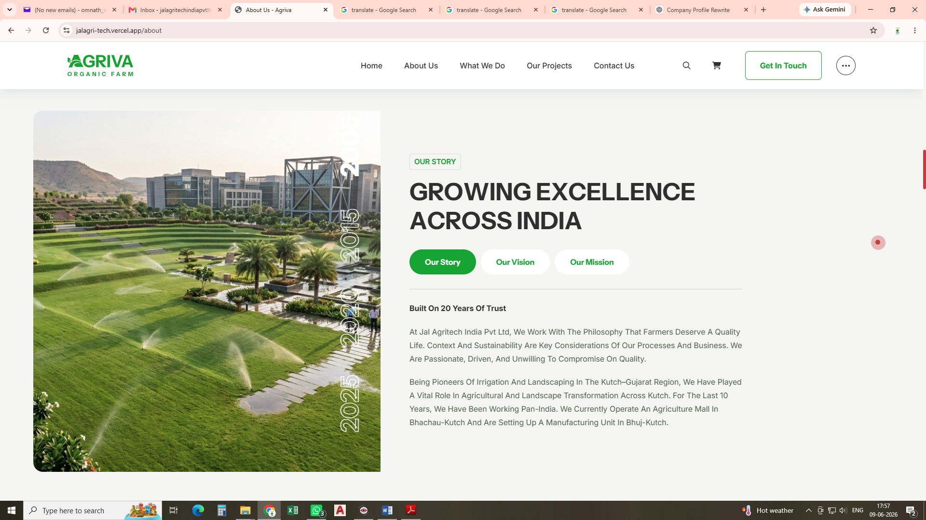

Our Story

At Jal Agritech India Pvt. Ltd., we believe that farmers and corporate clients deserve the highest quality of life through sustainable and innovative agricultural, irrigation, and landscaping solutions. Sustainability, efficiency, and long-term value are at the core of our business practices and decision-making processes. We are passionate about what we do, driven by excellence, and committed to delivering superior quality without compromise. Our focus is on creating reliable, environmentally responsible solutions that enhance productivity, conserve resources, and contribute to a greener and more sustainable future.
As pioneers in irrigation and landscaping in the Kutch–Gujarat region, Jal Agritech India Pvt. Ltd. has played a vital role in transforming agriculture and landscapes across Kutch and beyond. With over 15 years of industry experience, we have successfully expanded our operations across India, delivering innovative, sustainable, and high-quality solutions in irrigation, agriculture, landscaping, and environmental development.
Today, we operate an Agriculture Mall in Bhachau, Kutch, and manage nursery businesses in Bhuj (Kutch), Adas (Anand, Gujarat), Unnao, and Ayodhya (Uttar Pradesh). Strengthening our commitment to innovation and manufacturing excellence, we are also establishing India's first Polyester Barbed Wire manufacturing unit in Bhuj, Kutch, Gujarat. This pioneering initiative reflects our vision of introducing durable, sustainable, and advanced products to the Indian market while supporting the growth of agriculture, infrastructure, and green development across the nation.
Through our expanding Pan-India presence, strong technical expertise, and unwavering focus on quality, Jal Agritech India Pvt. Ltd. continues to contribute to the development of modern agriculture, efficient irrigation systems, sustainable landscaping, and innovative manufacturing solutions.

Our Vision

Pioneers of Change
We aspire to be the premier provider of innovative, sustainable, and high-quality solutions in irrigation, agriculture, landscaping, and environmental development. Our commitment is to consistently exceed client expectations through excellence, affordability, reliability, and environmentally responsible practices.
As pioneers of change, we deliver distinctive and sustainable solutions that contribute to a healthier ecosystem while enhancing the quality of life of our clients. Through innovation, thoughtful design, and a passion for sustainability, we create environments that inspire, engage the senses, and support long-term growth and prosperity.

Our Mission
To deliver innovative, sustainable, and cost-effective solutions in irrigation, agriculture, landscaping, and environmental development that create lasting value for our clients, corporate partners, government organizations, and communities.
We are committed to providing comprehensive, end-to-end services—from survey, planning, and design to supply, installation, project execution, operation, maintenance, and after-sales support—while upholding the highest standards of quality, reliability, safety, and professionalism.
With a dedicated team of irrigation engineers, landscape architects, horticulturists, and technical specialists, we serve a diverse clientele including government departments, public sector undertakings, industrial organizations, infrastructure developers, educational institutions, hospitality projects, commercial establishments, and agricultural enterprises. Our solutions are designed to enhance agricultural productivity, optimize water management, promote environmental sustainability, and create aesthetically pleasing and functional landscapes.
Through continuous innovation, advanced technologies, and environmentally responsible practices, we strive to conserve natural resources, improve ecosystem health, and contribute to the development of greener, more resilient communities. By fostering long-term partnerships and consistently exceeding expectations, we aim to be a trusted leader in delivering sustainable growth and transformative environmental solutions across India.

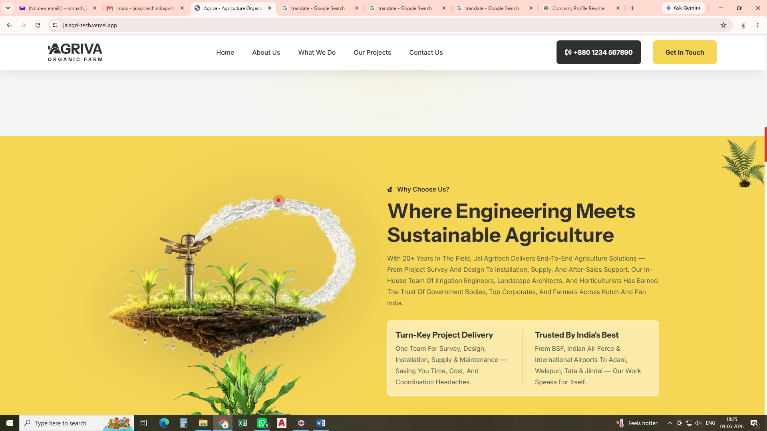
With over 20 years of industry experience, Jal Agritech India Private Limited provides comprehensive end-to-end agricultural, irrigation, and landscaping solutions. Our services cover every stage of a project, including site survey, planning, design, product supply, installation, commissioning, and after-sales support.
Backed by a dedicated in-house team of irrigation engineers, landscape architects, horticulturists, and technical specialists, we deliver innovative, sustainable, and cost-effective solutions tailored to the needs of our clients. Our commitment to quality, reliability, and customer satisfaction has earned us the trust of government organizations, leading corporate clients, institutions, and thousands of farmers across Kutch, Gujarat, and throughout India.

Note: આ ભાગ Irrigation Landscaping માં add કરવાનો છે

What We Do ( Our Projects)
  - Landscape Projects
  - Vertical Gardens
  - Miyawaki Forests
  - Terrace Gardens
  - Atomization Irrigation
  - Rain Gun Irrigation
  - Dust Separation
  - Fountains

Dust Suppression, Soil Erosion & Rock Erosion Control Projects
We have successfully executed specialized projects focused on dust suppression, soil erosion control, and rock erosion stabilization across industrial, infrastructure, mining, environmental, and land development sectors.
Our solutions are designed to minimize airborne dust, prevent soil degradation, stabilize slopes and exposed surfaces, and protect landforms from the adverse effects of wind and water erosion. By utilizing advanced irrigation systems, hydroseeding, vegetation establishment, geotextiles, erosion control measures, and sustainable environmental engineering practices, we help improve site safety, environmental compliance, and long-term land stability.
We have also successfully undertaken dust suppression and erosion control projects for coal mines, coal handling plants, conveyor belt systems, mining corridors, and surrounding road networks. These projects were implemented to control fugitive dust emissions, improve air quality, reduce environmental impact, enhance worker safety, and ensure compliance with environmental regulations. Our solutions include sprinkler-based dust suppression systems, misting systems, green belt development, hydroseeding, slope stabilization, and vegetation-based erosion control measures tailored to challenging mining and industrial environments.
These projects contribute to environmental conservation, improved air quality, reduced land degradation, enhanced site aesthetics, and sustainable ecosystem development. With extensive experience in mining, industrial, commercial, government, and infrastructure sectors, we deliver customized dust control and erosion management solutions that provide long-term environmental and operational benefits.

Terrace Gardens
You can present it professionally in your company profile, brochure, or presentation as:
"Our company successfully completed India's second-largest terrace gardening project at the prestigious Smritivan Earthquake Memorial & Museum, Bhuj–Kutch, Gujarat. This landmark green infrastructure project demonstrates our expertise in large-scale landscape development, sustainable horticulture, irrigation systems, and innovative environmental solutions."
Or a shorter version:
"Proudly executed India's second-largest terrace gardening project at the renowned Smritivan Earthquake Memorial & Museum, Bhuj–Kutch, showcasing our excellence in landscaping, irrigation, and sustainable green development."
For a company achievements section:
Key Achievement
- Successfully completed India's second-largest terrace gardening project at Smritivan Earthquake Memorial & Museum, Bhuj–Kutch.
- Designed and executed large-scale terrace landscaping with advanced irrigation and horticultural solutions.
- Contributed to the development of one of Gujarat's most iconic environmental and memorial destinations.

Specialized Waterproofing & Rainwater Harvesting Works at Smritivan Terrace Garden Project
As part of the prestigious terrace gardening project at Smritivan Earthquake Memorial & Museum, Bhuj–Kutch, our company successfully executed critical waterproofing and rainwater harvesting works that formed the foundation for the long-term durability, sustainability, and environmental performance of the terrace landscape.
The scope included Integral Cement-Based Waterproofing Treatment for roofs, terraces, balconies, and landscaped deck areas. The treatment comprised meticulous surface preparation, application of cement slurry mixed with waterproofing compounds, installation of fiberglass reinforcement cloth with specified overlaps, and protective cementitious layers designed to provide superior resistance against water ingress.
To further enhance waterproofing performance, APP (Atactic Polypropylene Polymer) Modified Prefabricated 5-Layer, 3 mm Thick Waterproofing Membrane reinforced with non-woven polyester mat was installed over a bitumen primer coat, ensuring long-term protection against seepage, moisture penetration, and structural deterioration.
In addition, our team implemented an efficient rainwater harvesting and drainage management system to facilitate the collection, conveyance, and sustainable utilization of rainwater. This system contributes to water conservation, reduces surface runoff, and supports the environmental objectives of the project.
These specialized waterproofing and rainwater harvesting works played a vital role in protecting the terrace garden infrastructure, preserving structural integrity, enhancing water sustainability, and ensuring the long-term success of one of India's landmark terrace landscaping projects.

Following the waterproofing treatment, a comprehensive drainage and protection system was installed comprising 40 mm thick HDPE Drain Cells with a minimum compressive strength of 1000 kN/m², minimum surface void area of 60%, and internal void area of 90%, laid in accordance with the manufacturer's specifications. To ensure effective drainage, soil retention, and erosion control, a 700 GSM Coir-Based Geotextile conforming to IS 15868 (Part 1 to 6) was provided over erosion-prone slopes and embankments as per IS 15872:2009, securely anchored using stainless steel staples at specified intervals. Additionally, a 250 GSM non-woven Filter Geotextile Membrane made of 100% polypropylene with 2 mm thickness was installed as a separation and filtration layer, preventing soil migration while facilitating free movement of water. This integrated drainage and geotextile system ensured efficient stormwater management, slope stabilization, root-zone protection, and long-term sustainability of the terrace landscape.
Following the completion of the waterproofing, drainage, and geotextile protection systems, carefully selected landscape plantations were established across the terrace garden. The plantation works included a diverse mix of ornamental shrubs, ground covers, cacti, succulents, native species, and forest species selected for their aesthetic value, adaptability to local climatic conditions, ecological significance, and low maintenance requirements. The planting design was developed to create vibrant and visually appealing green spaces while enhancing biodiversity, improving microclimatic conditions, minimizing soil erosion, and promoting long-term environmental sustainability. The integration of specialized waterproofing, advanced drainage infrastructure, rainwater management systems, and scientifically planned plantation techniques ensured the successful development of a resilient, self-sustaining, and environmentally responsible terrace landscape.
To ensure efficient water and nutrient management, the project incorporated a state-of-the-art Weather-Based Automated Irrigation and Fertigation System. The system utilizes real-time weather data and environmental parameters to automatically regulate irrigation schedules and fertilizer application, optimizing water consumption, improving plant health, and enhancing overall landscape sustainability.
The automated system was designed to deliver precise quantities of water and nutrients to different plantation zones, including shrubs, ground covers, cacti, succulents, native species, and forest vegetation, based on their specific requirements. This intelligent approach minimizes water wastage, reduces operational costs, and promotes healthy plant growth throughout the landscape.
In addition to the design, supply, installation, and commissioning of the automation system, the project also includes comprehensive Operation and Maintenance (O&M) services for a period of five years. This ensures continuous monitoring, preventive maintenance, system optimization, replacement of defective components as required, and sustained performance of the irrigation and fertigation infrastructure, thereby safeguarding the long-term success of the terrace landscape.

Our Services

Survey & Site Assessment
A detailed survey and site assessment are conducted to evaluate existing site conditions, topography, soil characteristics, water availability, drainage patterns, vegetation, and project requirements. This process helps identify opportunities and constraints, ensuring the development of efficient, sustainable, and cost-effective irrigation, landscaping, and environmental solutions tailored to the specific needs of the project. The collected data serves as the foundation for accurate planning, design, and successful project execution.

Design & Planning
Our Design & Planning process focuses on developing efficient, sustainable, and customized solutions based on detailed site assessments and client requirements. This includes conceptual design, layout planning, hydraulic calculations, irrigation network design, planting schemes, landscape master planning, material selection, and project scheduling. By integrating technical expertise, innovative approaches, and environmental considerations, we ensure that every project is optimized for performance, aesthetics, resource efficiency, and long-term sustainability.

Turn-Key Installation
We provide complete turn-key installation services, managing every stage of project execution from procurement and logistics to installation, testing, and commissioning. Our experienced team ensures the seamless implementation of irrigation systems, landscaping works, water features, environmental projects, and related infrastructure in accordance with approved designs and quality standards. With a focus on safety, efficiency, and timely delivery, we provide fully operational solutions that meet client requirements and ensure long-term performance and reliability.

Consultation & Support
We provide expert consultation and continuous support throughout every stage of the project lifecycle. Our team offers technical guidance, project planning assistance, system optimization, troubleshooting, and operational recommendations to ensure maximum efficiency and performance. From initial concept development to post-installation support and maintenance, we work closely with clients to address their needs, deliver practical solutions, and ensure the long-term success and sustainability of their irrigation, agriculture, landscaping, and environmental projects.

Maintenance

Annual Maintenance Contracts (AMC)
Our Annual Maintenance Contract (AMC) services ensure the long-term performance, reliability, and efficiency of irrigation systems, landscapes, Miyawaki, fountains, and environmental infrastructure. Through scheduled inspections, preventive maintenance, system testing, repairs, component replacement, and technical support, we help minimize downtime and extend the lifespan of project assets. Our dedicated maintenance team ensures that all systems operate at optimal efficiency while preserving the health, appearance, and sustainability of the project throughout the year.

On-Call Repairs
We provide prompt and reliable on-call repair services to address unexpected breakdowns, system malfunctions, and operational issues. Our experienced technical team responds quickly to diagnose problems, perform necessary repairs, and restore system functionality with minimal downtime. Whether for irrigation systems, landscaping infrastructure, fountains, pumps, automation controls, or related equipment, we ensure efficient troubleshooting and timely solutions to maintain uninterrupted performance and operational efficiency.

General Landscape Maintenance
Our General Landscape Maintenance services are designed to preserve the health, beauty, and functionality of outdoor spaces throughout the year. Services include lawn care, pruning, trimming, weeding, fertilization, plant health management, irrigation system monitoring, pest and disease control, seasonal planting, and overall site upkeep. With a focus on sustainability and horticultural best practices, our skilled team ensures that landscapes remain vibrant, safe, and aesthetically appealing while promoting long-term plant health and environmental well-being.

Drainage & Grading
Our Drainage & Grading services ensure proper land shaping and water management to protect landscapes, infrastructure, and agricultural areas from erosion, waterlogging, and runoff issues. Through precise site grading, contouring, slope stabilization, surface and subsurface drainage systems, and stormwater management solutions, we create efficient water flow patterns that enhance site functionality, improve soil health, and support long-term sustainability. Our solutions are tailored to site-specific conditions, ensuring optimal performance and environmental compliance.

Landscape Lighting Maintenance
Note ;- Cancelled this point

Outlets
Jal Agro Mall – Bhachau – Kutch
Jal Agro Mall was established with the vision of creating a one-stop destination for all agricultural needs by bringing together a comprehensive range of farming products, technologies, and services under one roof. Our objective is to empower farmers across Kutch and Gujarat with high-quality, reliable, and innovative solutions that enhance productivity, optimize resource utilization, and improve farm profitability.
We are dedicated to supporting the farming community by providing premium agricultural inputs, modern irrigation solutions, expert technical guidance, and advanced farming technologies. Our focus is to help farmers achieve higher yields, improve soil health, conserve water resources, and adopt sustainable agricultural practices that contribute to long-term success and a better quality of life.
To ensure access to the best products and services, we have partnered with leading manufacturers and trusted brands in irrigation systems, seeds, fertilizers, crop protection products, farm machinery, automation technologies, landscaping solutions, and other allied agricultural sectors.
Backed by expert consultation, quality assurance, and dedicated customer support, JAL Agro Mall has become a trusted partner for farmers, helping them embrace modern agriculture and achieve sustainable growth across Kutch, Gujarat, and beyond.

Neelkanth Nursery, Bhuj
Neelkanth Nursery, located in Bhuj, was established with the vision of providing high-quality live plants, pots, planters, gardening tools, and landscaping essentials for residential, commercial, institutional, and corporate projects across Kutch.
We are committed to offering a diverse range of healthy plants, ornamental species, avenue trees, flowering plants, indoor and outdoor plants, decorative planters, gardening accessories, and horticultural products that enhance the beauty, functionality, and sustainability of every space. Our focus is on delivering superior-quality products, expert horticultural guidance, and dependable service to homeowners, landscape professionals, businesses, institutions, and corporate clients.
With a passion for greenery and environmental stewardship, Neelkanth Nursery actively supports landscaping, plantation, urban greening, and environmental development initiatives throughout the region. By combining quality products with dedicated customer support and technical expertise, we help create vibrant, healthy, and aesthetically appealing environments that contribute to a greener and more sustainable future.
Through our extensive product range, professional services, and commitment to excellence, Neelkanth Nursery strives to be the preferred destination for all gardening, plantation, and landscaping requirements across Kutch and Gujarat.

Bholenath Nursery, Adas – Anand, Gujarat
Bholenath Nursery, located in Adas, Anand, Gujarat, was established with the vision of providing high-quality live plants, pots, planters, gardening tools, and landscaping essentials for residential, commercial, institutional, and corporate projects across Gujarat and neighbouring states.
We are committed to offering a diverse range of healthy plants, ornamental species, avenue trees, flowering plants, indoor and outdoor plants, decorative planters, gardening accessories, and horticultural products that enhance the beauty, functionality, and sustainability of every landscape. Our focus is on delivering superior-quality products, expert horticultural guidance, and dependable service to homeowners, landscape professionals, businesses, institutions, and corporate clients.
With a strong commitment to environmental stewardship and sustainable landscaping, Bholenath Nursery supports plantation drives, urban greening initiatives, landscape development projects, ecological restoration programs, and large-scale afforestation efforts. Our experienced team works closely with clients to provide customized solutions that meet project requirements while promoting long-term plant health and environmental sustainability.
Backed by extensive nursery infrastructure, quality plant material, and efficient logistics, Bholenath Nursery serves clients not only across Gujarat but also throughout 10–15 neighbouring states in India. Through quality products, professional expertise, and dedicated customer support, we strive to be a trusted partner and preferred destination for gardening, plantation, landscaping, and environmental development projects nationwide.

Boond Agritech, Unnao – Uttar Pradesh
Bund Agritech, located in Unnao, Uttar Pradesh, is our sister concern and serves as an important center for irrigation, landscaping, plantation, and agricultural development activities. The farm is dedicated to implementing modern irrigation technologies, sustainable landscaping practices, and large-scale plantation projects that promote efficient resource utilization and environmental sustainability.
Through Bund Agritech, we undertake the cultivation and maintenance of a wide variety of live plants, ornamental species, avenue trees, and landscape materials, supporting projects across residential, commercial, institutional, corporate, and government sectors. The facility also serves as a demonstration and development site for advanced irrigation systems, horticultural practices, and landscape management techniques.
With a strong focus on quality, innovation, and sustainability, Bund Agritech contributes to our mission of delivering integrated agriculture, irrigation, landscaping, and environmental solutions while supporting green development initiatives across the region.

Garden Care, Ayodhya – Uttar Pradesh
Garden Care, located in Ayodhya, Uttar Pradesh, is our sister concern specializing in nursery development, live plant production, pots, planters, and allied horticultural products. The facility is dedicated to cultivating and supplying a wide variety of high-quality plants, ornamental species, flowering plants, avenue trees, indoor and outdoor plants, and decorative landscaping materials to meet the diverse needs of residential, commercial, institutional, corporate, and government projects.
With a strong focus on quality, plant health, and customer satisfaction, Garden Care offers an extensive range of decorative pots, planters, gardening accessories, and horticultural products that enhance the beauty and functionality of indoor and outdoor spaces. The nursery serves as a reliable source of quality planting material and landscape products, supporting landscaping, plantation, urban greening, and environmental development initiatives.
Through professional horticultural practices, sustainable cultivation methods, and dedicated customer support, Garden Care contributes to our mission of creating greener, healthier, and more aesthetically appealing environments while serving clients across Uttar Pradesh and neighbouring regions.

Trading
Our company is engaged in the trading and supply of a comprehensive range of products for agriculture, irrigation, landscaping, horticulture, and environmental development projects. We source and deliver high-quality products from leading manufacturers to meet the diverse requirements of farmers, contractors, government departments, corporate clients, institutions, and landscape professionals.
Our product portfolio includes:
- Automation Irrigation Systems
- Drip Irrigation Systems
- Sprinkler Irrigation Systems
- Lateral Pipes and Fittings
- PVC Pipes and Fittings
- HDPE Pipes and Fittings
- HDPE Electrofusion Fittings
- Compression Fittings and Irrigation Accessories
- Water Filtration and Fertigation Systems
- Pumps, Valves, and Control Equipment
- Garden Pots and Decorative Planters
- Live Plants and Nursery Products
- Fertilizers and Plant Nutrients
- Pesticides and Crop Protection Products
- Agricultural Seeds
- Gardening Tools and Equipment
- Agricultural Tools and Tackles
- Landscape Materials and Accessories
- Polyester Wire, Nets, Ropes & Barbed Wires
With a strong distribution network and strategic partnerships with reputed manufacturers and brands, we ensure the availability of quality products, competitive pricing, timely delivery, and reliable technical support. Our commitment is to provide complete and cost-effective solutions that enhance agricultural productivity, water-use efficiency, landscape development, and environmental sustainability across India.

Manufacturing

Innovation in Advanced Fencing Solutions
Despite being a young and dynamic R&D-driven company, we have rapidly established ourselves as innovators in the field of fencing and agricultural infrastructure solutions. Within just two years of our research and development journey, we have successfully developed and commenced manufacturing of Polyester Synthetic Wire, GI Wire, and advanced fencing products designed for durability, sustainability, and long-term performance.
Our most significant achievement is the development and commercialization of Polyester Barbed Wire, an innovative fencing solution that is being introduced for the first time in India. This breakthrough product combines the strength and durability of high-performance polyester materials with the functionality of conventional barbed wire, offering superior resistance to corrosion, weathering, and environmental degradation.
The introduction of India's first Polyester Barbed Wire reflects our commitment to research, innovation, and indigenous product development. Through continuous R&D and advanced manufacturing practices, we aim to create cost-effective, sustainable, and high-quality fencing solutions for agriculture, infrastructure, industrial, and environmental applications across India.
This pioneering achievement marks an important milestone in our vision of building a strong, technology-driven manufacturing ecosystem and establishing a nationally recognized brand in advanced fencing and protection systems.

Strategic Business Partnership
We work together as business channel partners through Jal Agritech India Private Limited and Innovative Filament Private Limited, combining our expertise to deliver innovative and high-quality products for agricultural, industrial, and infrastructure applications.
Innovative Filament Private Limited is a leading manufacturer of Polyester Wire Nets and Ropes, known for producing durable, high-strength, and weather-resistant products for diverse industry requirements. Through this strategic collaboration, both companies leverage their technical capabilities, manufacturing expertise, and market reach to develop innovative solutions for customers across India.
As part of our commitment to continuous innovation and product development, we commenced the manufacturing of Polyester Barbed Wire in 2025. This advanced fencing solution offers several advantages over conventional materials, including corrosion resistance, durability, low maintenance requirements, lightweight installation, and long service life, making it suitable for agricultural, industrial, commercial, and environmental protection applications.
This partnership reflects our shared vision of delivering sustainable, cost-effective, and technologically advanced products that meet the evolving needs of our customers while contributing to the growth of modern agriculture, infrastructure, and environmental development sectors.

Future Growth & Brand Vision
As part of our long-term growth strategy, Jal Agritech India Private Limited aims to further develop and establish Polyester Barbed Wire as a recognized and trusted brand in the agricultural, industrial, infrastructure, and environmental sectors.
Building upon our collaboration with Innovative Filament Private Limited, we are committed to continuous product innovation, quality enhancement, and market expansion. Our vision is to position Polyester Barbed Wire as a sustainable, durable, and cost-effective alternative to conventional fencing products, offering superior performance, corrosion resistance, low maintenance, and long service life.
Through strategic branding, technological advancements, expanded distribution networks, and customer-focused solutions, Jal Agritech India Private Limited aspires to create a strong national presence for this product and establish it as a preferred fencing solution across India. Our goal is to build a brand synonymous with quality, reliability, innovation, and sustainability, contributing to the advancement of modern agriculture, infrastructure, and environmental protection.
Note : ફોટા Innovative ની સાઈડ પર લઈ લેવા
Smart Irrigation
Drip, sprinkler, and fully automated irrigation systems engineered to maximize water efficiency, reduce labour, and improve crop productivity. Our smart irrigation solutions deliver the right amount of water at the right time, helping conserve resources while boosting yield and ensuring healthy plant growth.

Landscape & Plantation
Premium landscape design, Miyawaki forests, and turnkey plantation solutions that transform spaces into sustainable, thriving green environments. From concept and execution to long-term maintenance, we deliver aesthetically pleasing landscapes with ecological and lasting value.
Agriculture Products Supply & Services
We offer a complete range of irrigation products, pipes, fittings, fertilizers, plants, planters, and agricultural essentials, backed by our in-house manufacturing capabilities. From product supply to technical support, we provide reliable, high-quality solutions—all under one roof for seamless project execution.

Home
Jal Agritech India Pvt. Ltd. brings over 20 years of expertise in irrigation, plantation, landscaping, and sustainable agriculture solutions. From pioneering projects across Kutch, Gujarat, to successfully executing turnkey projects for leading corporate clients and government organizations across India, we provide innovative, end-to-end solutions that maximize productivity, conserve natural resources, and create long-term environmental value. With a commitment to quality, sustainability, and customer satisfaction, we transform ideas into efficient, future-ready agricultural and landscape solutions.

Contact Us
Over 20 years of expertise in irrigation, landscape design, plantation, and turnkey agriculture projects across Kutch, Gujarat & Pan India. Trusted by government organizations and India's leading corporate clients, we deliver innovative, sustainable, and end-to-end solutions that maximize productivity, conserve resources, and create lasting environmental value.

What Our Clients Say
Blogs converted to chatGPT

